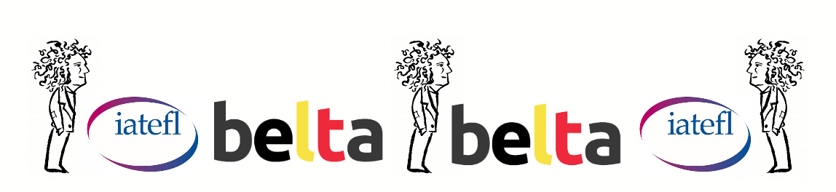

Joris De Roy Memorial Grant

APPLICATION FORM BELTA DAY 2026

I hereby apply for the Joris De Roy Memorial Grant to win IATEFL Associate membership for one year, the early-bird registration fee to attend the IATEFL conference 2027 in the United Kingdom and free entry to BELTA Day 2027.

The IATEFL International Conference 2027 will take place in Birmingham, England, from 6 April to 9 April.

I confirm that
- I have read and understood the general information page about the Joris De Roy Memorial Grant;
- I reside in Belgium;
- I have not won a BELTA grant before;
- I am available in the period 6 - 9 April 2027 and will attend the IATEFL conference;
- I will print out a Certificate of Attendance, scan the certificate upon my return and send it to beltabelgium@gmail.com;
- I agree to write a blog post for the BELTA blog about the conference;
- I agree to pay my IATEFL associate membership and the IATEFL 2027 early-bird conference fee myself before sending proofs of payment and my banking details to BELTA so they can reimburse me.
PLEASE USE BLOCK CAPITALS
Full name:

Institute – function:
Email address:
Signature:

